Pixel Monarch Project Report

Virginia Tech
ECE 2564 - Fall 2025
Project 1: Pixel Monarch
Samin Rahman
GitHub Username: saminzr
Repository Link:
https://github.com/VT-ECE-2564-assignments/f25-proj1-saminzr.git
Date: 10/30/2025

Report Summary
This report documents the implementation of Pixel Monarch, a resource-management game developed for the MSP432 microcontroller. Pixel Monarch is an interactive, resource-management simulation that features multiple screens, UART-based input handling, finite state machines, and non-blocking code architecture. This report covers project description, system architecture diagram, code quality self-assessment and the implementation of additional bonus features.

Project Description
The objective of this project is to design, develop, and implement an interactive, resource-management simulation game called Pixel Monarch. The game tasks players with balancing People (PE), Treasury (TR), and Territory while responding to events that threaten the kingdom. The game incorporates Main Menu screen that allows players to navigate between Play Game, Instructions, and High Scores. The Game Screen displays resources, territory grid, and year counter. The game uses UART-based system for responding to events (Flood, Famine, Raid, Calm Period). The game ends with Game Over screen showing survival years with option to restart. The game allows for baud rate switching via LaunchPad button with visual LED feedback. All core requirements from the project specification have been implemented. The list for them as follows:
- Non-blocking code architecture
- UART communication at multiple baud rates
- Finite state machine for screen management
- Correct implementation of Main Menu, Game Screen, and Game over
- High score tracking
- Random event generation and territory management
- All four event types with appropriate resource deductions and territory changes.
- Territory grid with controlled (green) and lost (red) regions.

Figure 1, Main Menu:
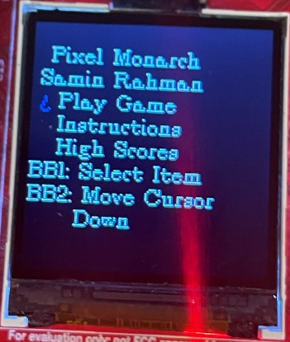
Figure 2, Game Screen:
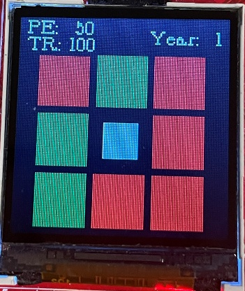
Figure 3, Game Over:
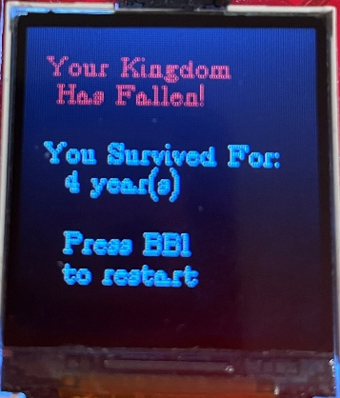

Microcontroller-Based Embedded System Architecture
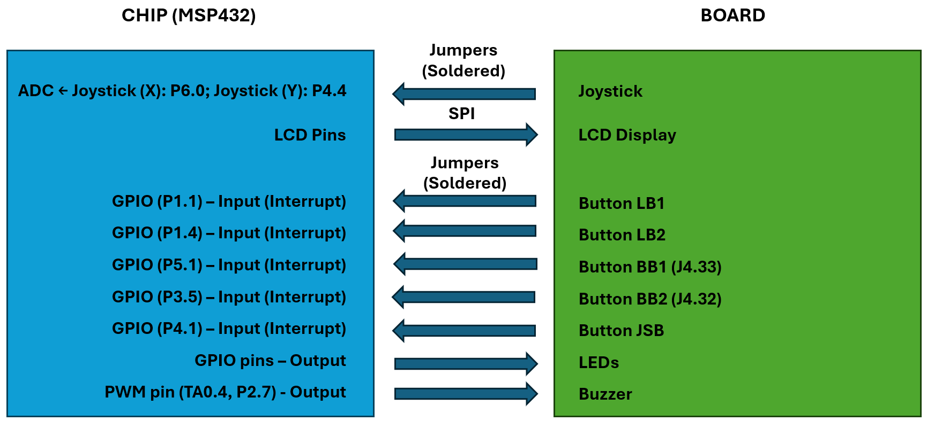

All peripherals in a microcontroller — such as GPIO, timers, ADCs, UART, SPI, and I²C — are ultimately controlled and accessed through pins on the chip. These pins are connected internally to the CPU and peripheral modules via a system bus that uses memory-mapped registers for configuration, data transfer, and status monitoring.
In a memory-mapped I/O architecture (used by most modern MCUs, including the MSP432), each peripheral register is assigned a specific address in the processor’s memory space. This allows the CPU to interact with hardware peripherals using the same load and store instructions used for normal memory operations.
- Input pins: When configured as inputs, the electrical signals on the physical pins are sampled by the hardware and stored in associated input registers. The CPU can then read these registers to determine the logic level or analog value currently present on the pins.
- Output pins: When configured as outputs, writing a value to the corresponding output register updates the logic level driven on the pin. Thus, software control of pin states is achieved by writing to these memory-mapped registers.
Each peripheral typically has multiple registers — for example, direction control (input/output), data input/output, interrupt enable/flag, and mode selection registers. Through these registers, firmware can configure and manipulate hardware behavior directly.
The two-axis joystick consists of two potentiometers arranged orthogonally: one for the X-axis and one for the Y-axis. Each potentiometer acts as a variable voltage divider, generating an output voltage proportional to the deflection of the joystick. Because the joystick outputs are continuous voltages rather than digital logic levels, a microcontroller cannot interpret them directly via GPIO pins. Instead, they must be sampled using an Analog-to-Digital Converter (ADC).
Key ADC registers include:
- Control registers that enable the module, select sampling modes, and set conversion resolution.
- Memory control registers that map physical input channels (e.g., ADC input A0, A1) to memory result registers.
- Result registers (e.g., ADC14MEM0, ADC14MEM1) that hold the digital conversion results.
When an ADC conversion is triggered—either via software or timer hardware—the selected analog input pin is sampled, converted, and the resulting digital value is placed into the appropriate memory register. The CPU reads these result registers to obtain the measured voltage.
Timer_A is a general-purpose timer that operates through memory-mapped registers. It contains:
- A counter (TAR) that increments based on a clock source.
- Capture/Compare Registers (CCR) that define timing events.
- Output modes that control how a connected pin behaves when the CCR value matches TAR.
Each CCR corresponds to a specific hardware output channel (e.g., TA0.1, TA0.2), which can be mapped to particular pins on the microcontroller via the pin-mux system.
To generate a PWM waveform, Timer_A is configured in up mode:
- The CCR0 register defines the period (and hence frequency).
- Another CCR register (e.g., CCR1 or CCR2) defines the duty cycle by selecting the point during the period when the output transitions.
Once configured, the timer hardware autonomously drives the pin, producing a stable PWM waveform without additional CPU involvement. The buzzer is connected to such a microcontroller pin that supports the Timer_A output function.
The selected pin (P2.7) must be configured for the appropriate peripheral function (secondary or tertiary function), enabling the Timer_A hardware to drive the pin instead of the GPIO module.
For the piezo buzzer:
- The PWM frequency determines the audible pitch.
- A 50% duty cycle typically produces the strongest tone.

Code Quality
The aspects are described in the table below. It was especially challenging to keep the functions within 50 lines, commenting the code, and keeping the architecture non-blocking throughout.
The code follows all specified quality requirements:
Code Quality Aspect | Maximum Points | Points Expected | Justification
Comments | 10 | 10 | Code is adequately commented
Constants/Macros | 20 | 20 | Almost all numeric values (except 0/1 and some LCD text row-column values) are defined as macros
Function Length | 30 | 30 | No function greatly exceeds 50 lines (max: 55 lines)
No Global Variables | 40 | 40 | All state stored in Application struct, HAL struct, and function static variables; no global variables used
Non-Blocking Code | 20 | 20 | LB1 immediately controls LL1 at any point during game execution
TOTAL | 100 | 100

Bonus Features
Bonus Feature | Maximum Points | Points Expected | Status
LED for Building Selection | 25 | 25 | The Boosterpack RGB shows which building is currently selected  Cursor = Blue  Grandma = Red
TOTAL | 25 | 25

